CO1 – AT 2 Query Processing
Vedvyass M – 192324267

Aim :

To develop a Python program to read vehicle registration data from a CSV file and owner information from a JSON file, clean and standardize the data, merge both datasets using the registration number, and generate a validated dataset according to the specified database schema.

Processing performed :
- Read CSV using pandas.read_csv().
- Read JSON using Python's json module.
- Remove duplicate registration numbers using drop_duplicates().
- Standardize registration numbers to uppercase and remove spaces.
- Standardize dates to YYYY-MM-DD.
- Merge both datasets using registration_number.
- Handle missing owner information using "Unknown" or "Not Available".
- Validate required columns according to the database schema.
- Remove records without a registration number.
- Export the cleaned dataset as validated_vehicle_data.csv.

Example CSV file :

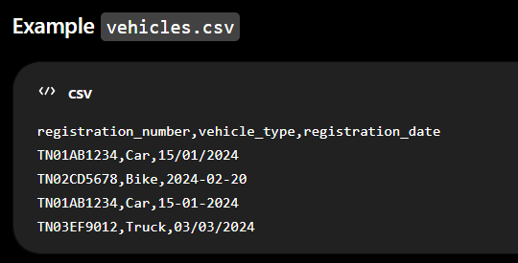
CODE :

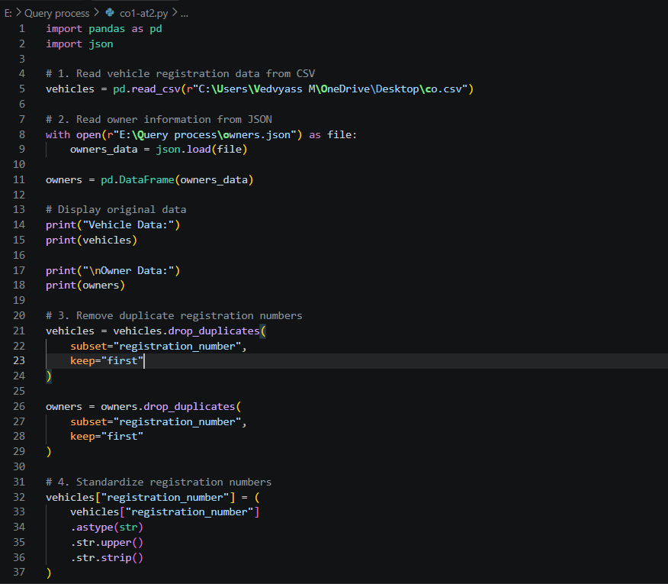
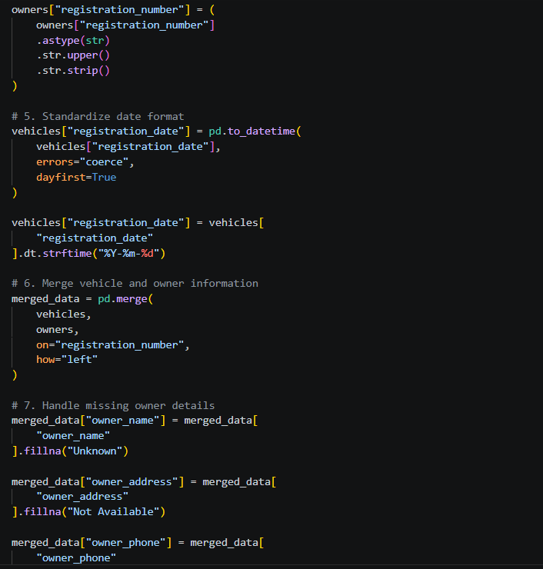
OUTPUT :

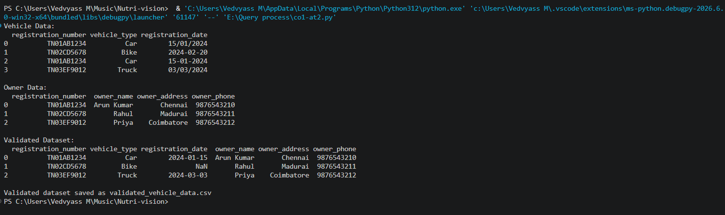

Result :

The vehicle registration CSV and owner JSON datasets were successfully cleaned, standardized, merged, and validated using Python. Duplicate registration numbers and missing owner details were handled, and inconsistent dates were converted into a standard format. The final validated dataset was saved as validated_vehicle_data.csv.

